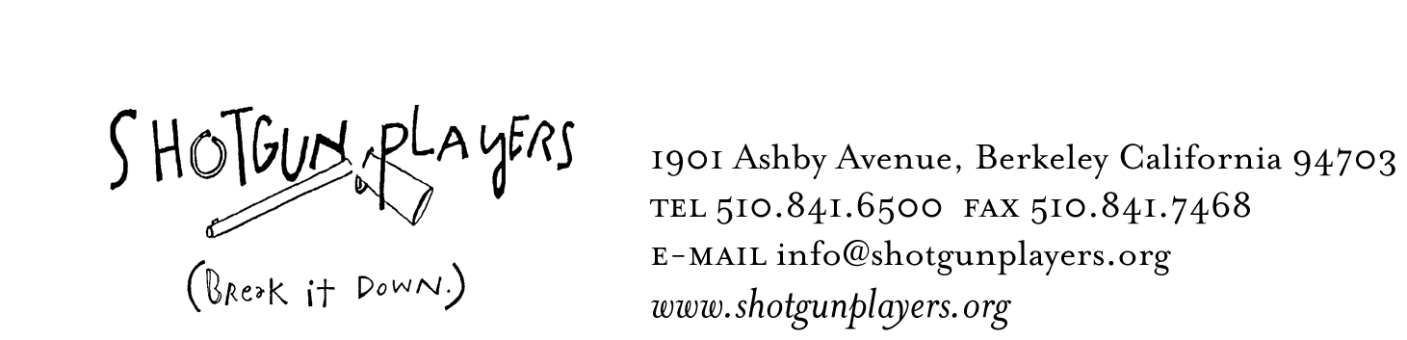

December 8, 2008
FOR IMMEDIATE RELEASE
FOR INFORMATION:
LIZ LISLE at 510-841-6500 x302

SHOTGUN PLAYERS PRESENT

Beowulf:
Beowulf is back!

A Thousand

Years of Baggage
A Banana Bag & Bodice SongPlay

WRITTEN BY JASON CRAIG
MUSIC BY DAVE MALLOY
DIRECTED BY ROD HIPSKIND

“That was fucking awesome!
...the most thoroughly enjoyable theatrical display I've seen yet this year”
– East Bay Express
“brilliantly funny, muscular, and plain irresistible” – SF Bay Guardian
“exhilaratingly eclectic and comic” – SF Chronicle

BERKELEY—After 1,000 years of telling and retelling, who decides what the facts actually are? Flawed heroes, sympathetic monsters and haughty professors collide as one of the most twisted stories in the literary cannon comes to life—with an infectious musical score! Beowulf: A Thousand Years of Baggage performs for One Night Only -Thursday, January 8th at The Roda Theater in Berkeley.

After an incredible run at the Ashby Stage, Shotgun Players and Banana Bag & Bodice are at it again. In April 2009 the original production will move to New York’s Lower East Side and take up residence at The Henry Street Settlement. In order to raise funds for Shotgun’s most ambitious and far flung project yet, we’re throwing a one night showing and after-party at the incredible Roda Theater in downtown Berkeley.

Part homage, part parody, Beowulf is a whole new take on the ironclad battle tales of medieval Europe. After twenty five performances in Berkeley, the party in King Hrothgar’s mead hall was just getting started! Through the generosity of big brother Berkeley Rep, the show will live again for one night on the west coast before moving to the largest theater town in America.

Banana Bag & Bodice is an ensemble theatre company who work to redefine the traditional notion of performance through original texts and music. Shotgun Players is a company who exist to overstep all rational boundaries in the theatrical canon with its bold innovative commissions.

Dave Malloy, a composer and musician who has worked with theatres and artists all over the Bay Area has created a stunning original score for Beowulf. Dave Malloy has also served as music director for Shotgun Players productions of Cabaret, Ragnarok and Ubu for Predisdent. Using music, Mr. Malloy subverts traditional expectations of the characters in Beowulf, and explores the tale instrumentally from multiple perspectives. It’s bizarre, it’s loud, it’s live. It’s Beowulf!

The performance will be directed by Rod Hipskind with Costume Design by Kaibrina Sky Buck with the ensemble, Props by Sig Hafstrom, Lighting by Miranda Hardy, and Stage Management by Hanah Zahner-Isenberg.

The cast of Beowulf features Banana Bag & Bodice company members Jason Craig and Jessica Jelliffe, as well as Chris Kuckenbaker (The Skriker, As You Like It), Anna Ishida (Blood Wedding, Bright Ideas), Beth Wilmurt (The Death of Meyerhold) and Shaye Troha. The band, led by Dave Malloy (Cabaret, Ragnorak) on prepared piano and other technology, features Shotgun Company member Daniel Bruno (Cabaret, The Forest War, Mother Courage) on percussion, Chris Broderick (Three Musketeers, The Forest War) on Clarinet, Andre Nigoghossian on Guitar & Jennifer Baker on Trombone.

CALENDAR LISTING

WHAT: Opera versus criticism in mead-soaked Scandinavia! Flawed heroes, sympathetic monsters, and haughty professors collide as one of the most twisted stories in the literary cannon comes to life—with an infectious musical score! Shotgun Players and collaborating company Banana Bag & Bodice raise the roof at the Roda Theater to fund their run next spring in New York City.

WHEN: Thursday, January 8th, 8PM

WHERE: The Roda Theater, 2025 Addison Street (Berkeley Repertory Theater), Berkeley

TICKET PRICES: $30. Includes a hot party with hosted bar after the show! Advance reservations strongly advised.

For more information go to www.shotgunplayers.org or call 510.841.6500

For press photos, please download images from our website, or contact
Liz Lisle at liz@shotgunplayers.org, or (510) 841-6500 x302

