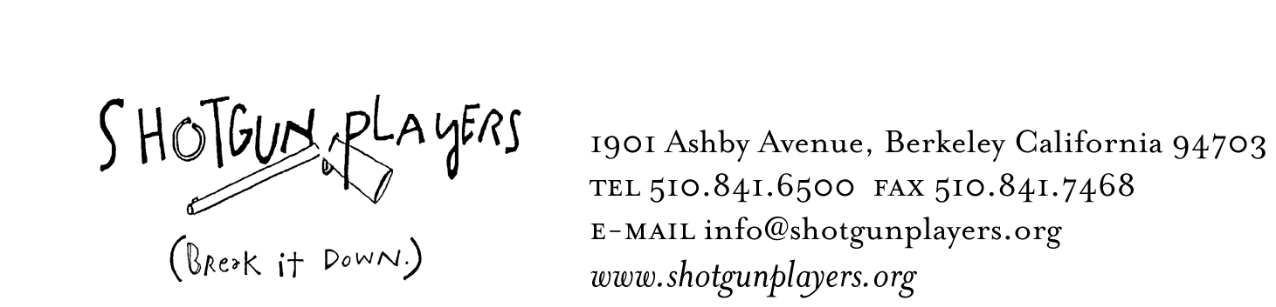

April 13, 2009
FOR IMMEDIATE RELEASE
FOR INFORMATION:
LIZ LISLE at 510-841-6500 x302

SHOTGUN PLAYERS PRESENT

Faust, Part 1

By Mark Jackson
Freely adapted from Johann Wolfgang Goethe's
FAUST, DER TRAGÖDIE ERSTER TEIL

Directed by Kevin Clarke and Mark Jackson

BERKELEY— Reeling between stylish comedy and gothic horror, Faust, Part 1 tells the story of a famous but unfulfilled scientist who makes a deal with the devil to find passion with a beautiful young commoner. Pulled by the conflicting forces of desire and responsibility, Faust hurtles headlong toward a grim fate. Are his actions according to his own will? Or does Faust fall prey to the coercion of his malevolent visitor. Faust, Part 1 previews May 20 and 21, opens May 22, and performs Thursday – Sunday through June 28 at the Ashby Stage.

“For what is a man profited, if he shall gain the whole world, and lose his own soul?”-Matthew 16:26.
In the modern climate, there is a certain amount of soul searching going on. An old and famous tale of underdealings and unfair advantages such as Faust, Part 1 begs the question: What really is at the heart of being a passionate human? Does the ability to act without remorse and without accountability really serve us in the end?

Goethe (1749 – 1832) was a central figure in German literature, philosophy and scientific thought at the turn of the 19th century. His work, which ran parallel to the Expressionist movement in European art, was immensely influential on the poetry, drama, music and philosophy that emerged over the next century across the west. Goethe had an instinctual sense that the European sensibility was moving away from empiricism and towards emotionality; towards the part of humanity that is beyond fact, hard to describe, and difficult to investigate. His eight hour opus Faust is an excellent example of this exploration in dramatic terms.

In Faust, Goethe shifts style constantly. Shakespearean poetics give way to colloquial rhythms. Then someone sings a song or a dance breaks out. Faust and Mephistopheles, to say the least, cannot be divided neatly into the good guy and the bad guy. Gretchen is likewise an interesting figure. She travels a very complicated emotional journey and is in a way the beating heart of the play, with Faust the adrenaline, and Mephistopheles the reason and conscience.

-more-
2-2-2

In his fourth collaboration with Shotgun Players, Adaptor/Director Mark Jackson creates another stunningly visceral world with set and character. With Faust, Part 1, Jackson looks into the rich texture of Goethe’s imagination, and teases out the best bits from over 900 pages of the original text.

The performance will be directed by Mark Jackson and Kevin Clarke. Clarke is also designing the Costumes. Set Design by Nina Ball, Lighting by Joan Arhelger with assistance from Krista Smith, Sound by Matt Stines, and Stage Management by Michelle Smith with assistance by Ashley Dawn.

The cast of Faust, Part I features Shotgun company member Zehra Berkman (Macbeth, Cryptogram), as well as Blythe Foster (Macbeth), Phil Lowery, Peter Ruocco (Macbeth) and Dara Yazdani. Mark Jackson will take on the part of Faust.

CALENDAR LISTING

WHAT: Reeling between stylish comedy and gothic horror, Faust tells the story of a famous but unfulfilled scientist who makes a deal with the devil to find passion with a beautiful young commoner. Pulled by the conflicting forces of desire and responsibility, Faust hurtles headlong toward a grim fate. Are his actions according to his own will? Or does Faust fall prey to the coercion of his malevolent visitor.

WHEN: Previews Wednesday, May 20-Thursday, May 21. Opens Friday, May 22. Runs Thursday – Saturday at 8PM, Sundays at 5PM through June 28.

WHERE: The Ashby Stage, 1901 Ashby Avenue, Berkeley, CA 94703

TICKET PRICES: Opening Week Performances May 20, 21, 23 & 24 are Pay-What-You-Can. Opening Night Friday, May 22 is $30 with drinks and hors d’oeuvres included after the show. Regular performance nights are $18 Thursdays, $22 Friday and Sunday, $25 for Saturdays. Advance reservations strongly advised.

For more information go to www.shotgunplayers.org or call 510.841.6500

For press photos, please download images from our website, or contact
Liz Lisle at liz@shotgunplayers.org, or (510) 841-6500 x302

